Dog on Dog Fight Protocol
If you are involved in a dangerous situation, like a dog fight/dog attack, The Most Important and Vital Piece of Information Everyone on Site Needs to Know Immediately is -
>>>> WHERE YOU ARE <<<<
Clearly Shout Out Over the Radio and Repeat your Location Several
Times
"New Barn/Paddock/Yard/Car Park etc etc"
DO NOT WASTE TIME EXPLAINING WHAT THE SITUATION IS BEFORE EVERYONE KNOWS WHERE YOU ARE.
The 2 Main Things to Remember...
>>>>>>> NEVER PULL THEM APART <<<<<<<<
and
>>>>>>>>> PIN THEM TOGETHER <<<<<<<<<<<
In a dog fight scenario where a dog has gripped on to another dog and isn't letting go, trying to pull them apart will cause more harm than good as you could rip arteries/veins/tendons
Use all your strength to pin the attacking dogs head so it cannot move its head at all and can't cause any more damage.
We pin the attacking dog's head to stop it from ragging - dogs rag other dogs to rip tendons / rip limbs/rip veins and arteries and ultimately kill the dog.
KEEP YOUR NECK AND FACE AWAY TO PROTECT YOURSELF

When Everyone Hears a Location Being Shouted over the Radio
Run Straight to that Location
If You are Walking a Dog When you Hear the Alarm - >>> Look After Your Own Dog First <<<<
>>> Put it back in its kennel safely <<<<<<
>>> Do Not Panic and Create a New Situation <<<<

Once you have shouted your location several times -
if you're able to, give details what the incident is.
The dog being attacked will be screaming and yelping in pain. Don't let that worry you - keep pinning them together until help arrives.
Once help arrives - The most effective way to get the attacking dog off IS TO CHOKE IT OFF
If it's Wearing a Collar - Twist it Tight and Hard Around the Top of its Neck, Until the Dog Begins to Pass Out.
If it's not wearing a collar - Use a Slip Lead and Wrap it Around the Highest Point of its Neck (the weakest part) and Pull Tight.
Once The Attacker Starts to Lose Consciousness and Releases its Grip, Get it Way Clear of the Other Dog.
Revive it by Stroking it Rapidly, Talking to it and Massaging its Neck Area.
Be Cautious in Case it Quickly Wakes Up and Panics.
Thoroughly Check Over Both Dogs For Injuries Take Any Injured Dogs to the Vet
Please Remember, The Attacker is Just As Scared and Will Be Just As Shaken Up.
Take it For a Calm Walk Off Site to Settle and Calm it.
Please Do Not Put it Straight Back in its Kennel.
Make Sure You Don't Have Any Injuries Yourself.
—----------------------------------
Loose Dog Protocol
If you're walking a dog and it gets loose from you, Relax, Crouch Down and try Calling it back to you. There's a good chance it will run back towards you. If you can't get it back within a couple of seconds, Loudly and Clearly shout "Loose Dog"
Several times over the radio so everyone hears it.
The 3 Key parts of Information Everyone Needs To Know Immediately is -
>>> What the Situation is - i.e Loose Dog <<<
>>> Which Dog is Loose <<<<
>>> Where is the Dog Heading <<<
If the dog is loose on site - whoever is closest to the Main Large Silver Gate by Kitten Unit when the loose dog alarm has been called -
>>> CLOSE IT <<<
You just need to pull the bottom bolts out of the ground for it to close. This gate will keep the loose dog contained on site
(Unless it's Chihuahua sized that can fit through the bars!).
If you're at the end of the drive, Close the gate in-between the 2 Farm Gates leading into the fields.
These Gates are to be Immediately Closed as soon as the alarm is raised and are to Remain Closed until given the all clear.
The dogs usually run towards the Paddock or Down the Drive, if they go up towards the paddock Close the Gates leading up there behind them
(The one by Laundry and the one leading into the Car Park)
The only other way they can escape off site is if they cut across the Horse Fields through the fence and then through the Far Hedges - it's incredibly rare they'll try this as they won't have ever been walked there before and won't have any association to go that way.....But it has Happened. If they do, keep Eyes on them and Communicate with Everyone where they're Heading.
Some dogs may try and attack the Horses - Careful not to get kicked!
DO NOT DIRECTLY CHASE THE DOG IF THE DOG IS FACING YOU
It May Spook Them or it May Turn into a Game.
Walk Calmly but Efficiently Around Them.
If a member of staff is quite close to them and close to getting them BACK OFF AND GIVE THEM SPACE
If you're walking a dog when You hear the loose dog alarm Focus On Your Own Dog Before Offering Assistance If you're not close to a kennel block-
Keep yourself and your dog well out of the way
If you can safely and quickly put it away in its kennel/outdoor run then great Do NOT Panic and Rush as you could cause your own dog to get loose (This happened several years ago where a handler put a dog in the outrun... ...and ran off without closing the door... So there were then 2 loose dogs on site to deal with...)
If you're walking a dog friendly dog and you know the loose dog in question is also dog friendly - You can potentially use your dog to lure them to you. If you're unsure about the dogs temperament then keep well away.
If you're walking a dog aggressive dog and hear the Loose Dog alarm Get yourself inside ASAP - Back Office/Any Kennel Block/Reception/Vets/
Outside Kitten Unit/Potentially the Café
(Beware of other dogs in there and other areas) It doesn't matter if you can't offer assistance Just keep Your Own Dog Away and Safe.
If you're in a position where you're walking a dog aggressive dog, and a loose dog is running towards you, or the loose dog is dog aggressive and there is no-where for you to go - Put your dog as Close Behind you as Physically Possible and Try and Scare the loose dog away from you
(Shout at it, Stamp your feet towards it etc) We would rather have a loose dog than a dog fight!
You will probably have a split second to do this and it's the safest option for you.
In doing so You may add a couple of precious extra seconds for other handlers to grab the dog
Regarding volunteers on site with dogs - usher them quickly and safely past the gate to the area outside of barns or keep them safely tucked away by the outside cafe area. But Remember to keep them all Separate from each other and remind them to do so.
If we have any stranger aggressive dogs loose on site - usher all members of Public and Volunteers Inside Immediately - Doesn't matter where, anywhere inside and keep them there until the All Clear has been given.
Make sure someone tells everyone in the cafe to stay put until given the all clear
If a dog runs down the drive and onto the road
Keep eyes on it For as long as possible so we can get a good sense of which direction it is heading
The supervisor that day will quickly delegate who is to (carefully) drive after it and who is to stay behind and hold the fort
As Soon as the Dog has been Safely Caught Give the All Clear Over the Radio Please Don't Forget to do this
If a dog gets loose from you - It's happened to everyone many times and will happen to everyone again at some point.
It's nothing to be embarrassed or ashamed about - There are 70+ dogs on site that are constantly moving around - It Happens
Tips to Prevent Loose Dogs
• Hold onto the Lead Tightly with your Hand Through the Loop.
• Keep the Toggle Down on Slip Leads
• Close Doors/Gates Behind You
Check and Double Check Kennel Doors are Closed and Locked when putting dogs back
Be cautious when getting dogs out of the kennel and ensure it's done correctly
• Keep a close eye on Volunteers and correct their lead handling if needs be
—---------------------
Introducing Very Nervous/Reactive Dogs to Strangers
The most important aspect of introducing nervous/stranger reactive dogs to people, is that they're handled correctly.
Dogs that react negatively to strangers - barking/lunging/snapping etc have learnt that if they react negatively, it keeps the scary people away.
The dog needs to experience strangers without having to react negatively to learn that the strangers don't pose a threat to them.
Before you even have the dog out, make sure you have plenty of chopped up sausages/chicken from the cafe and give them to the clients.
The process is very similar to introducing nervous dogs to other dogs.
The best phrase when working with nervous dogs is
LESS IS MORE
The LESS Attention and Interaction they have from strangers, the MORE they will Trust them and see they're Predictable and not a Threat.
If new people were trying to give them affection and attention constantly - the dogs won't see them as safe and will be especially wary of them.
It's like a stranger running up to you in the street and keeps trying to give you a hug and pat your head - it probably won't go down well..
This process needs to be done slowly and not to be rushed.
Worst Case Scenario.. A Client gets bitten = No-one Wins
The dog needs to experience strangers without having to react negatively
You need to completely take control of the situation and make sure you've explained to the people not to attempt to give them affection - repeat yourself if needs be.
Don't be afraid to be quite stern and abrupt with people if required. They need to know the rules.
It's for their own safety as well as the dogs safety at the end of the day.
You need to be very relaxed - but aware of the situation.
By talking to the people and having a conversation with them helps the dog relax with them also.
If it's rushed and people hastily try to give them affection too soon, the dog will very quickly decide they're not to be trusted and will most likely react defensively.
To Begin With -
Have the new people walking AHEAD of the dog making sure they know to Completely Ignore the dog- no eye contact, no trying to touch them, no talking to them - nothing.
Walk the dog beside you or slightly behind you (on a short but relaxed lead) and at a safe distance behind the people (10 metres or so more if the dog is struggling to settle) and follow exactly where they're walking.
This allows the dog all the time it needs to assess the people to slowly realise they're no threat, as the people are walking away from the dog, there's no eye contact, no tension, which means it's all very calm and the dog also learns the people are predictable.
It also allows the dog to familiarise itself with their scent.
What you're looking for is relaxed and calm behaviour from the dog - losing focus of the people in front, turning their back on them, sniffing, exploring, toileting and a relaxed posture.
Depending on the dog and how traumatic it's background and association to people is, this may take a couple minutes or several hours of work before they Settle.
Do Not Rush This - This will take Time and Patience
When the dog starts to relax, with the people in front, and is displaying calming signals, you can slowly begin to decrease the distance to the people in front. Whilst walking behind the clients, you can ask them to casually drop a couple of sausages on the floor without facing the dog or giving the dog any attention, but continuing the walk
You're looking for the dog to really settle being around them and eating treats off the floor and either forgetting the people are there or positively associating the treats to them.
If the dog isn't food motivated then focus on just calm walking with them.
If the dog is toy motivated you can use a tennis balls for later in the paddock.
But high value treats usually work best.
Secondly As long as the dog is settled and relaxed, eating treats off the floor and starting to relax with the people.
Walk alongside the clients
BUT Always Put Yourself In-between the People and the Dog
By doing this you are creating a safe barrier between the people and the dog.
This will allow the dog to feel safer as you're communicating to the dog that you're in control of the situation.
If the dog is in-front of you - you're basically asking the dog to guard you and you're also sub-consciously asking the dog to let you know if the people are safe or not..
That's a lot of responsibility for a dog and they will often make the wrong choice.
Having the dog in front of you also communicates to the dog that you're asking them to fend for themselves and that you're not looking after them.
If walking alongside the people is too much for the dog at this moment in time then drop back behind them until the dog settles
Whilst walking alongside, if the dog is very relaxed and settled you can stop with the people (Still having the dog beside/just behind you) and you can ask the clients to throw a few sausages on the floor.
If the dog is very relaxed and eating the treats off the floor - then (one client at a time) - you can ask them to hand feed the dog - they can hold the treat out and if the dog approaches them then it's the dog's choice.
You always need to be directly in-between the people and the dog and be alert for any wary or tense behaviours
When giving treats to a dog - People tend to get Complacent and Stroke the dog under the chin or stroke its head after giving it a treat - Remind them beforehand NOT to give Affection to the dog.
Affection might be too much for the dog resulting in the dog reacting and you'll have to start all over again, and it will be harder this time as trust will be broken.
Continue walking with the people, especially if the dog seems very tense and unsure.
If the dog is very relaxed and accepting treats well, go for a long walk together off site.
If the dog is very settled with them after a long walk, then you can proceed to go into the paddock.
After several laps around the paddock on lead, as long as the dog is very settled, you can either let go of the lead or take the lead off the dog altogether. Keep close to the clients at all times. Remind them to be very relaxed and not to give the dog affection as of yet - just treats for now until the dog is ready.
If the dog is toy motivated you can pass the toys to the clients for them to throw. Be cautious about the clients bending down to pick toys up if the dog is close by it may spook the dog as it can be quite intrusive to bend down close to the dog and potentially unsafe for the clients - it's always best for you to pass the toys to the clients for a little while until the dog settles and relaxes well with them.
Every Dog is Different
They may take longer to settle and it may take a few sessions for them to learn to trust and be completely relaxed with the clients
Take your Time
Relax but be Aware of the Situation.
Read your dog well and take it slower if the dog is tense, wary and reacting.
—---------------------------------
Taking Dogs to the Vets
When a dog is taken to the vets for the first time, We have no idea how the dog will react.
Many dogs have a negative association with veterinary practices as they are usually not associated with anything pleasant - only stress and unpleasant
situations.
The dog may never have been to the vets before and may be very nervous
The Dog Handlers role when taking the dog to the vets is to
>> Protect The Vet
The vet will normally have to examine the dog to give it a very thorough health check.
This involves having to have their Face very very close to the dog, especially when using a stethoscope to listen to their heart.
The Dog Always has to be Restrained well
You need to make sure you have Complete control of their Head when the vet is examining them and vaccinating them.
Always be Ready in case the Dog Panics and Reacts
If the dog is wearing a collar, tuck your fingers underneath it so you have complete control.
If it isn't wearing a collar, you can use your lead to wrap around its neck to hold on to.
Try to be relaxed so as not to create any unnecessary tension.
Keep it as light, fun and relaxed as possible we want the dog to have a pleasant and positive experience at the vets.
Do not get Complacent with Any Breed of Any Age
Any Dog can React Negatively Unexpectedly and Quickly
—---------------------------
Dog Behaviour Assessment Guide
All dogs require a Behaviour Assessment before going to a home
These assessments allow us to see what the dog is comfortable with, what insecurities they have and will determine what circumstances they will require in their potential home.
In most cases, we have no idea how the dog will be in a home environment, as we can only give an educated guess on how they will be.
It may be a case with the individual dog that what you see is what you get.
However there are no guarantees, they may be perfect with us at the rescue but display negative behaviours in the home.
Or they may display negative behaviours in the rescue and turn out to be perfect in the home.
Assessments also protect the rescue if any negative altercations were to happen in the home.
If a dog displays negative behaviours in the home that we didn't witness here and a full assessment has been done with the dog, then it's all in our favour.
Or if negative behaviours were witnessed and documented here, and owners were made fully aware of them also, this is also in our favour.
When it comes to doing behaviour assessments on our dogs, we will, more than likely, have a very good idea of their temperament as they will have been with us for a short while before doing their assessment.
When doing any part of the Assessment
Always Protect your FACE and NECK
Always keep your face and neck away from the dog and always have your hand up in front of these vulnerable areas to protect yourself.
Even if the dog displays very calm and relaxed behaviours, always be ready in case they quickly react defensively at any point remember, in most cases, we don't truly know these dogs.
If at any part during the assessment you feel the dog is too nervous to proceed with a particular section, that still counts as part of the assessment.
Picking up for example, you can add the dog was 'too nervous to be picked up'
Just write in detail what behaviours the dog was portraying and why you didn't feel comfortable.
It's always worth making notes on the dog's temperament as soon as they come in to us, which will benefit you when it comes to writing up their assessment.
General Handling
What was the dog's temperament when it first came in to us?
Is the dog fine being handled?
Are there any areas the dog is sensitive or uncomfortable with being touched? If comfortable to do so, gently give the dog affection and test all the following areas -
• Eyes
• Ears
• Mouth
• Teeth
• Head
• Neck
• Chest
• Legs
• Paws
• Toes
• Claws
• Stomach
• Back
• Tail
Make sure not to be too intense when Assessing
Be Relaxed and Keep it Light and Keep it Fun
Always Be Casually Aware and ready for the dog to be Reactive
The dog may have sensitive areas - they may quickly be defensive or react in pain.
Especially around sensitive areas like the stomach and rear end
Some dogs may not like their eyes / paws being touched etc
Is the dog comfortable being picked up?
You can start by putting a little pressure on their underneath where you would usually pick them up.
If the dog is timid/unsure with you or very nervous, then there is no need to push this as it could provoke a reaction, as it's a very intrusive manoeuvre to pick a dog up.
Please do not pick up elderly dogs as there is no need.
You can simply put on their assessment they were too old to attempt to pick up
If the dog is a very large breed - then don't do your back in trying to pick it up!
How is the dog with being restrained?
If the dog isn't too nervous, Gently see how they are when being restrained.
Again be mindful of your Face and Neck areas
Behaviour Around People
How confident were they when they first arrived?
For this part of the assessment they need to meet a variety of people, or at least see how they are when close to people if they're very fearful.
You will, most likely, already have a very good idea of how confident they are with people.
How are they with men/women?
Be cautious who you choose to be Guinea pigs for this - volunteers are usually really good, just make sure they're not too over the top with affection with nervous dogs.
With nervous and scared dogs, make sure you ask the people you're using not to show them too much attention or affection see if the dog comes to them in their own time.
If they're very confident and relaxed, you can potentially see how they are in the café. This will usually be an unfamiliar environment to them so you will get a good sense of how they are in new environments.
Be cautious of other dogs in there and there will be public and potentially children in there.
When introducing them to unfamiliar people, how do they react? Are they
Keen to interact?
• Uninterested?
• Confident?
Excited?
• Bouncy?
• Boisterous?
shy?
Unsure?
Avoid completely?
Relaxed but choosing not to interact? Wary/Aggressive?
Regarding what age children they can potentially live with: Stray dogs can only live with children aged 5years+ (no exceptions) however, they are rarely suitable to live with children that young.
If there are very nervous/petrified/mouthing heavily/possessive and potentially aggressive behaviours displayed - then the age of children they can be rehomed with is strictly 16+, or adult only home depending on the severity of the behaviours.
Other behaviours and observations which may affect what age children they should live with -
• Excitable/boisterous behaviour
• Strength of the dog
• Reactive to dogs
• Different Breeds - powerful strong dogs
The age of the children can be negotiated as you can get some very mature 10 year olds and some very immature 18 year olds.
The children need to be confident and sensible with the dogs.
If there are young children in the home - you can guarantee they will have friends of a similar age that will visit at random times.
If we know the dog may be living with young Children.
An Extensive Assessment Must Be Done.
When it comes to deciding what age children dogs can live with -
We need to get this right
Ask several other handlers what their opinions are and ask if they have seen any with the dog before deciding what age they can live with and always check with the supervisor to make sure they agree.
The Kennel Supervisor will always be the one who will ultimately decide.
If we decide a dog can live with younger children
but we then see negative behaviours further down the line during its stay with us, then this needs to be addressed and the age of children will need to increase.
Behaviour Around Dogs
We need to assess the dog's temperament with and around other dogs as part of the assessment.
This will decide if they can potentially live with other dogs, or if they would be better suited as the only dog in the home.
Do a few on-lead mixes with a couple dogs of different temperaments - ideally a calm relaxed dog and then an excitable dog.
This gives us a great idea of how they will generally be like with dogs as they will most likely be calm or excitable.
If it's a male dog unsure of other dogs - maybe a mixing with a female might be best.
If the dog in question is unsure/scared/reactive towards the calm dog, then there's no need to proceed with an excitable dog as you can guarantee the nervous behaviour will intensify with an overly excitable dog.
If the dog appears to be very relaxed and enjoys the dog's company then there may be potential to live with other dogs. Or you may feel they will settle overtime but are not ready at present and require more canine socialisation.
If it's an older dog you're assessing and it seems relaxed with other dogs, advise it would most likely be best for it to live with an older compatible dog.
It is never guaranteed when doing assessments that they can live with other dogs, it just gives us an all-round general idea of what will work best for them.
Dogs Behaviour Around Other Animals.
Is there a prey drive? Are they overly focused on other animals/squeaky toys?
Are they focused or not fazed by cows?
What are they like with birds?
Will they suddenly chase objects flying in the wind?
Are they alert when on walks and looking out for other animals?
You may not spot this on the assessment as other animals never appear when we want them to.
When walking any dog - if prey drive behaviour is seen either before or after the assessment, make a note of it to add it onto their assessment when it's done.
Food Possession
When doing a food possession test, you just want to see if there is any nervous or possessive behaviour
Remember
You are only Seeing if there is a Reaction not to Push for one.
You can accidently Teach dogs to be food possessive! Which is why some already are.
Don't be complacent if you think you know the dog - some of the loveliest, friendliest and most playful dogs can surprise you when it comes to food possession!
All Wary Behaviours Stems from the Eyes of the Dog
You're looking for tense and wary behaviours.
Are they -
Focused on you/quickly glancing at you or focused on the food bowl? • Hovering over the food bowl
• Heckles up
Stiff and tense posture
Snarling
• Growling
• Snapping / Barking into the food bowl
Eating very very quickly - almost snapping into the bowl.
It's incredibly rare a dog will choose to bite you right away without giving several warnings first.
We want to spot and respect the signs of food possession and not to proceed any further with the assessment when we see any behavioural signs.
Make sure you're as relaxed as possible, if you're looking tense and very on edge - the dog won't feel comfortable either.
Avoid Direct Eye Contact Wherever Possible
It's best to do food possession tests in the dog's kennel as that's where they will have a routine with feeding.
Do not be overbearing. Stand/Crouch side on to the dog so it's less threatening.
Use a larger bowl than you normally would for the size of the dog - this is so there is more surface area for you to hold onto, it will not be as intense and safer for you as you can have your hands not so close to their mouth.
You want to put a fair amount of decent meat in the food bowl
if you don't put enough food, they can wolf it all down before you've even had a chance to start the assessment.
When you present them with a bowl of decent meat and place the bowl down -
Firstly
Just Stand at a distance. This is to see if they're comfortable with you being there.
Do not be Overbearing. Stand at a distance to the dog so it's less threatening.
• Are they hesitant to eat?
• Do they eat straight away? • Are they wary of you?
• Are they relaxed to eat?
• Are they relaxed but not interested in food at all?
Gently and Slowly move your foot closer to the food bowl whilst they're eating, if they're comfortable with this, then glide it side to side in front of the bowl, and then tap it gently if you're able to do so..
• Any wary behaviour?
• Growling?
• Glaring?
Frozen posture?
Snapping at your feet?
• Uncertainty?
•
Tense Behaviour?
Do they eat quicker?
If the dog is fine with this, and only if you feel confident to do so -
Crouch down Side On to the Bowl
If the dog is still very relaxed with this, gently move your hand that is closest to the bowl towards the bowl and see if you can move it around slowly and potentially take it away.
Don't Snatch it away, just move it Slowly at first
There is a fake rubber hand in the back office if you prefer to use that rather than your own hand.
Do Not put yourself at risk, think of the breed of dog you're assessing. Any breed of dog can be food possessive.
If it's a very large and powerful breed, make sure you're being extra vigilant on watching out for nervous and wary behavioural signs.
Always position yourself side on, this is so if you need to move quickly away, you can do so very easily and make sure your hand can be moved away quickly.
Do Not Push for a Reaction and Annoy the Dog
When you see any signs of tension/wariness it's up to you and the situation as to how far to proceed.
Do not put yourself at risk; if it doesn't feel right and you get a sense the dog really isn't comfortable, then you can stop there.
If you don't get a reaction when moving the bowl away from the dog, you can lightly touch their back or on their head again make sure you position yourself so if you need to move away quickly you can do.
Only do this if you haven't seen any tense or wary behaviours.
If the dog is potentially living with children then you need to be thorough.
Sometimes you may not be sure when it comes to food tests -
Some dogs can be nervous and scared to eat (but not possessive) but it comes across as very tense behaviour.
This may be because they may have been told off for eating before.

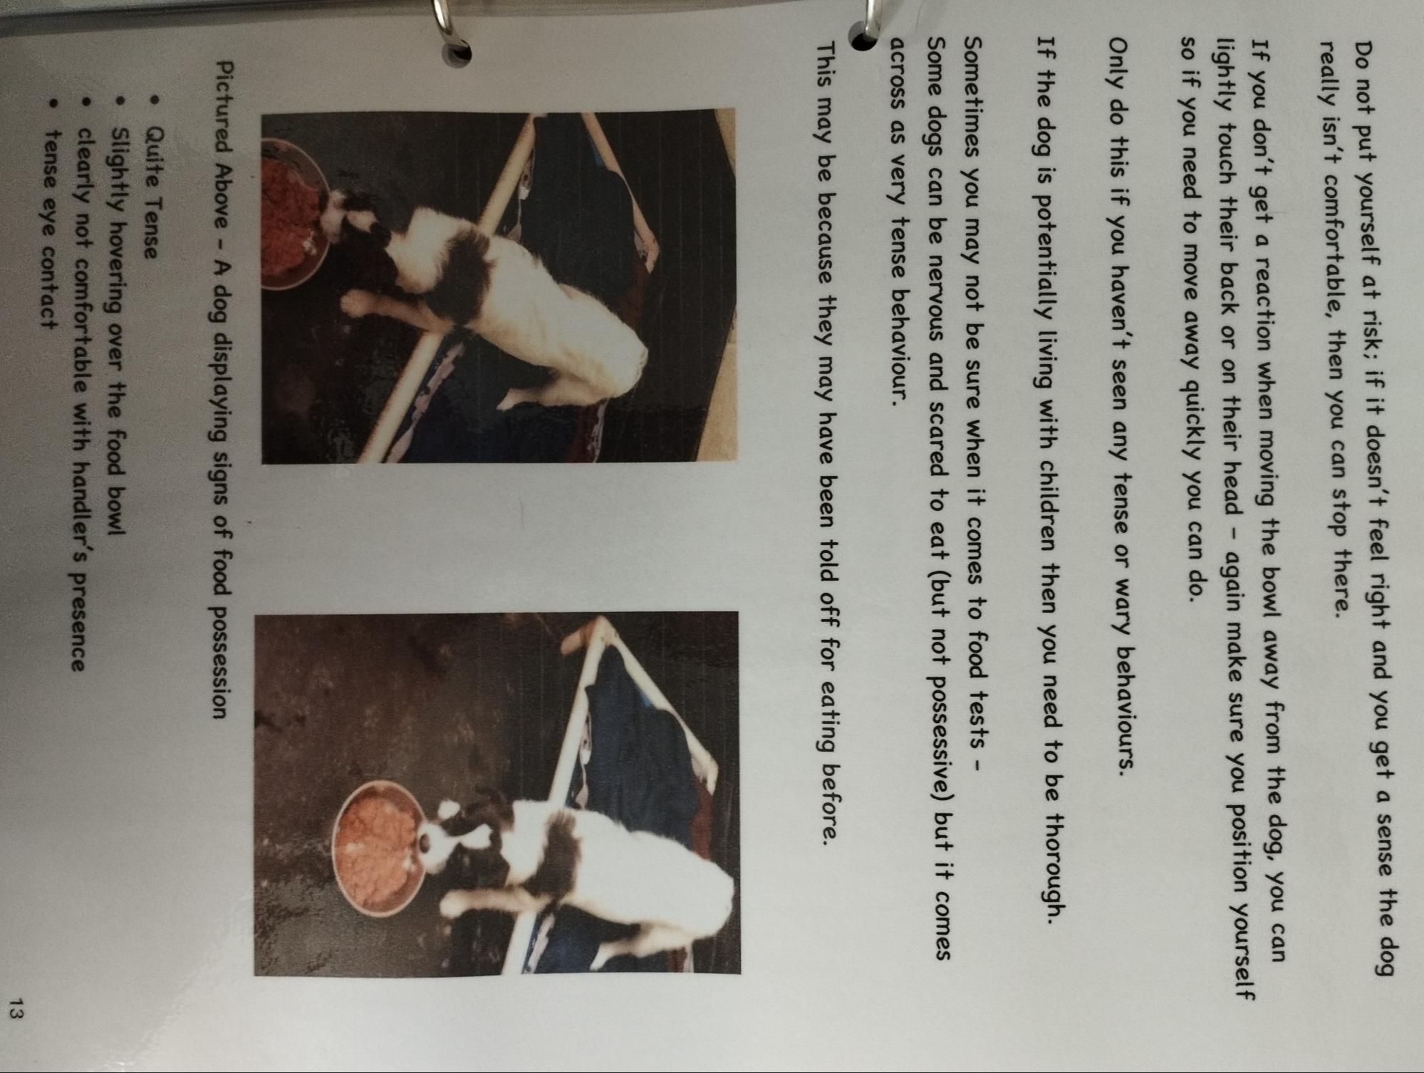

Pictured Above - A dog displaying signs of food possession
• Quite Tense
⚫
Slightly hovering over the food bowl
clearly not comfortable with handler's presence tense eye contact

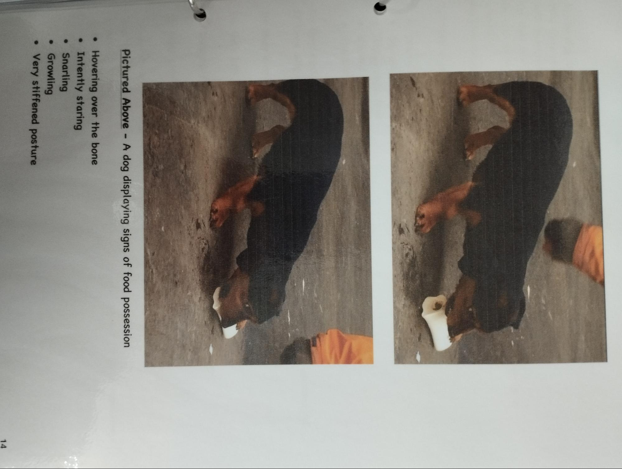

Pictured Above - A dog displaying signs of food possession
• Hovering over the bone
• Intently staring
• Snarling
• Growling
• Very stiffened posture

Toys
Is the dog toy orientated?
Will they chase but lose interest?
Will they play when really encouraged to do so?
Do they prefer just being with you?
Do you think they may play with toys in the future but are too nervous to at present?
Do they know what to do with toys?
Is there a particular toy they prefer?
Tennis balls
• Squeaky toys
Raggy rope toys
• Cuddly toys
• Footballs
Do they destroy toys in their kennel and the paddock?
If they only destroy toys in their kennel, it may be a sign of Separation Anxiety
Do they drop toys for you wanting to play fetch?
Do they bring toys up to you to play?
Do they dart towards you and quickly run away wanting to be chased?
Do they continuously take toys away from you?
To see if they're possessive over toys:
Use the same approach as food.
Crouch down close to them if they've got a toy - again try not to be overbearing and non-threatening.

Gently move your hand towards the toy
Are they -
• Focused on you or quickly glancing at you? Hovering over the toy?
• Heckles up?
• Stiff and tense posture?
• Snarling?
• Growling?
•
Snapping?
Are they vocal but in a playful manner?
• Do they act excited?
Do they continuously take the toy completely away from you?
If it feels safe to do so and you haven't seen any potentially possessive behaviour-
See how they react when attempting to take toys away
• Do they grip onto it?
• Do they pull away and try to run away?
• If you let go, do they try and push the toy into your hand inviting you to play?

Exercise and Play
• Does the dog pull on lead?
Are they gen-con trained?
• Could they benefit from basic lead skills?
• If they get over excited, are they mouthy?
If so, how hard? Does it mark the skin? and is it easily stopped?
• What do they do when off lead?
- Explore calmly?
- Charge around playing?
Just want to be close to you?
• What is their recall like?
Do they come back to you straight away when called?
- Are they easily distracted?
Do they ignore you?
- Does it turn into a game when you try and call them?
No matter how perfect their recall is -
Always note to keep them on lead for at least 8-12 Weeks.
This will allow time to -
Build a solid foundation of trust with their owners
• Work on their recall
• Familiarise themselves with their surroundings
• Socialise with other dogs/people under control
With very very nervous dogs the time scale to keep on lead will increase to 6 Months Minimum Especially dogs that could be a flight risk
With dog aggressive dogs, always advise to keep on lead and avoid popular dog walking areas and to avoid wide open spaces - e.g. the beach.
How are they in the Vets?
How were they for their general health check and being vaccinated?
Were they -
• Nervous?
• Timid? But tolerated the health check and vaccine
• Relaxed?
• Reactive?
•
Aggressive?
• Did they panic?
• Tense?
If you're unsure, ask the member of staff who took them down.
It usually says on their vet notes on analogue how they were as written by the vets
How are they with Traffic?
When walking them, take them to the end of the drive to see how they are with traffic.
You may be able to gauge how they are as you move closer to the road
Are they -
• Relaxed?
• Focused?
• Wary?
Reactive to fast moving traffic?
• Do they try and hide away?
• Do they panic?
• Do they try and lunge for traffic? (Usually a collie trait)
• Are they easily distracted?

In the Notes Section.
You can recap on any issues seen and can go into detail of what socialisation is required. (Dog, People, all round general socialisation with the outside world)
•
Is the dog fine with being left alone?
Do they panic when being left?
Do they try and chase you out of the kennel or are they vocal?
If so, then they will struggle being alone in the home and will require guidance on separation anxiety.
If there are any Aggressive or Possessive Behaviours witnessed during the assessment that staff weren't already aware about make sure it's Written on their Boards and make sure everyone is Fully Aware of Them
Be Sure To Write the Date of the Assessment Down!
If at any point of the assessment you feel you need a second opinion or are not confident or are uncertain on any behaviours seen, there's absolutely no harm or shame in asking another handler to re-do a certain part of the assessment if you
were unsure.
—--------------------------------
Mixing dogs
Before you even Begin -
You need to know as much about the individual dogs as possible..
• How old are they?
Neutered/Spayed? If not, it may not work as males will usually keep trying to mount - it's quite rare it works with unneutered males.
Are they comfortable with other dogs on lead? How do they react? Have they been offlead with other dogs, if so how are they? Have they ever had other dogs inside the home with them?
Are they toy orientated/possessive? If possessive make sure all toys are removed from the paddock beforehand same goes for toy/ball obsessed dogs! If they find a ball that's all they want to do and it's difficult to get a read on the dogs.
Are they comfortable with fast moving traffic? (for offsite walks) if not then walk calmly around the sensory garden.
How do they react when being told off by other dogs?
If a dog is too much for them will they tell it off?
Have they ever had any negative altercations with other dogs?
This valuable information will set you up as to how to approach the mix and how to best make it work as you'll have a great idea how the dog will react to different situations.
Don't do a mix without at least some knowledge about the dogs you are mixing!
Let the client know that if their dog snaps/growls or barks towards the dog that it's ok and it's just communication and to please let them do it - obviously if their dog tries to lunge and act aggressively towards the other then hold them back...!
You can guarantee that the client who says "Oh my dog will never do that" Then their dog definitely will!
People often panic when they do display these behaviours and tell their dog off for it.
Walking First
Explain the mixing process to the clients - they may be nervous about the safety of their dogs, ensure them it's a step by step process and it's all done as safely as possible as we try to spot the issue before there's an issue.
Before the dogs have any physical contact whatsoever, take them on a walk first, a good distance from each other.
A good distance being about 20 metres or so.
DO NOT RUSH IT YOU COULD SET THEM UP TO FAIL
If you rush it and let them meet straight away, and it starts with a close negative panic reaction (snap, bark, lunge, panic etc) within the first few minutes, it's incredibly hard to recover from that as their dog will be very nervous and defensive.
ALWAYS ALWAYS have the Less confident dog walking a good distance BEHIND the More confident dog.
In nearly every single case, it's the Client's dog who will be the more nervous one being new to the rescue, even if the client insists they're confident, you can guarantee they will, at least, be a little on edge being in the rescue environment.
If you're unsure, have the client's dog behind you anyway.
Having the more nervous dog walking behind will be so much calmer and more comfortable for them.
This allows time and space for them to assess the other dog to see they're no threat, because the 'sharp end' is walking away from them and there's no direct eye contact, and no tension.

Try and have the more confident dog facing the front to avoid any intense eye contact, they will no doubt, at least once, try and turn around and stare which can unsettle the more nervous dog.
Ask the clients to follow where you're walking so they can follow the other dog's scent.
What you're looking for is relaxed and calm behaviour from the dogs - losing focus of the dog in front, turning their back on them, sniffing, exploring, toileting, possible excitable behaviour and relaxed posture.
Once both dogs are displaying calming signs you can start to decrease the distance with the 2 dogs.
Do Not Rush This! It may take a few minutes.......half an hour...an hour for them to settle, if they don't at all then it's not going to work.
Look out for Avoidance Behaviour
Some dogs will subtly avoid other dogs - they may walk calmly right by their side - but will show zero interest in them and will turn away anytime the other dog tries to interact. If this continues with zero interaction then it's unlikely to work.
You may be happy walking alongside strangers in the street - doesn't mean you want anything to do with them let alone live with them!
Look out for subtle and sharp eye movements from the dogs. If they're displaying this, then they're unsettled with them and are still learning to trust them and want to keep an eye on them.
It's best and safer to walk them out the lane and turn Right up the road, the road is wider and there are more laybys to calmly let them interact if, and when, they're ready to do so. For a longer walk, when you get to the crossroads, take the Left and walk along there, it's usually very calm up there.
Letting them Interact on Walks
When you feel they're ready to interact when they're both calm
Keep it Brief initially
When they go nose to nose - keep it to Literally 1 second maximum before quickly encouraging them to continue walking.
Any longer than 1 second nose to nose and it will create tension between the 2 dogs - the more nervous one will most likely give -
- A Warning Snap
OR
- They will both explode in play together.
But more likely to Snap especially the first time meeting each other properly
Try not to pull them away with the lead as you could cause them to react, instead really encourage them to continue walking with a forward motion and keep it fun and light.
Do several very very brief nose to nose encounters before allowing them to interact properly. This can be every few minutes or longer depending on how calm they are.
You want them to interact positively - sniff each other (at the same time '69' is a bonus as it's shows mutual trust) and explore together - sniffing the same spot at the same time is great and when they're exploring together.
Interacting and calmly moving around each other is perfect.
Be Very Very Careful not to get the Leads Tangled.
When the dogs interact, they may circle each or quickly spin/play around each other.
You may need to quickly walk around them, at the same pace as them, to stop the leads getting tangled if they're spinning whilst interacting.
If they get tangled and become trapped very close to each other - They will quickly panic and snap at each other - which could result in a dog fight if not sorted quickly
Make sure the owners are pre-warned about this and they walk around with you too.
If they're walking together great, relaxed with each other, settled in each others company and are exploring together well, then you can progress to the paddock.
Mixing on Lead in the Paddock
Ideally the grass paddock is the best paddock to do the mix in as it's calmer being further away from New Strays, there are fewer toys dotted around and fewer hiding areas and blind spots where they could scrap (underneath the hedge/in the shed etc).
If needs be - the astro paddock is ok - be mindful as there's always an abundance of toys in there, so you may need to remove them beforehand.
Make sure everyone is aware you're mixing in the paddock and to keep all other dogs not involved in the mix out of the equation.
They need to be well away and out of sight from the paddock area when mixing it can be very distracting for the dogs and if there is a reactive dog it can sometimes cause a dog fight with the dogs you're mixing and ruin the mix! (it's usually volunteers that are unaware and will wander up, please tell them to walk down the drive)
Once in the paddock, 'our' dog will most likely be very excited and want to play as it will be familiar and settled with the paddock area.
Keep both dogs on lead and walk them both around the perimeter of the paddock first, it's still a brand new area for the new dog so it needs to be allowed time to settle.
Once you've done several laps of the paddock on lead, you can usually let the more nervous dog go off lead (again in nearly every single case, it's usually the client's dog). If you're unsure, or have two very boisterous dogs - have them both on long lines / slip leads and give the newer dog more freedom on lead.
This is their opportunity to do whatever they want to do, which is to explore the paddock on their own without the other dog hassling them and to learn the environment. They're usually relatively calm and just want to sniff and explore all the scents of the other dogs, it's rare they burst into play immediately but you never know what they'll do so be aware.
Keep walking round as it encourages them to walk with you and keep our dog on a short but relaxed lead close to you.
Dogs aren't daft and they know who's on lead and who isn't. We keep our dog on lead so their dog feels safer and will relax quicker.
Do not introduce toys at this point and remind the clients not to either.
When their dog begins to relax and gets more confident with and around the other dog you can gradually give our dog a little more freedom (add an extra slip lead/attach a longline). Again, keep walking around, it encourages the dogs to walk with us, to settle and interact.
If you stand completely stationary, so will the dogs and this could create tension and anxiety.
Play Behaviour
You want both dogs to be comfortable playing with each other, without one being more intrusive and boisterous than the other one would like.
If both dogs are initiating play with each other and it's not getting too boisterous or vocal then that's great.
Dogs will try varied techniques to get the other dog to play -
• Play Bowing
• Resting heir head on the other dogs shoulders
• Play Nipping
• Vocal - Barking/Growling
• Play Zoomies
• Hitting with Paws
• Chasing with Toys
• Loose body postures
• Body Slamming
If it feels too intense and the dog on lead is too over excited and too boisterous for the other dog, then keep it on lead to keep control of the situation until it reads the other dog well and listens to any warnings.
If one dog is far too playful and boisterous and you can see the other dog is uncomfortable / trying to avoid it / or if it's giving warnings but the other dog isn't listening or retaliating to the warnings, then the mix won't work and the warnings will get more severe, which will cause a negative escalation with the dogs.
What you're looking for is the dogs to be able to read each other well, have play moments but to have natural breaks from play themselves - to explore together then playful moments without us having to intervene to calm and settle the situation.
Letting go of the Lead
You may have a mix where you have two large dogs of a similar temperament - e.g. both very playful and boisterous, in this case have them both on a lead to control the situation if needs be.
Once you feel the dogs are very relaxed with each other, and there's no tension and it Feels Safe to do so, you can keep them attached to the long line but let of the lead. So the lead trails behind them so you can pick it up and control the situation quickly if required.
go
Do Not Rush This
You may feel it's not safe to get to this stage if the dogs are too nervous or ours is too intense.
If the lead is dropped and both dogs are relaxed with each other/playing well and reading each other well, then it is up to you to decide when is best to let them go completely off lead.
This is where you will get your exercise in and you need to be sure to stay close to them in-case you need to quickly engage or de-escalate any overly boisterous play.
Again - Do Not Rush This
Take your time with it, let them get used to each other with the lead trailing loose first, it's always a big step letting them go completely off lead together. You may spot behaviours preventing you from letting them off lead completely together.
Allow plenty of time to see how they are with each other.
Letting Dogs Off Lead
Once you feel it's time to let them off lead -
>> BE READY FOR A SUDDEN CHANGE IN BEHAVIOUR <<
Both dogs will know they are both loose and the dynamics could completely change.
They may burst into play and start bombing it round or be very wary and uncertain.
Be cautious and keep a sharp eye as -
• Play can quickly turn to Fear.
Fear can turn into Panic.
• Panic can turn into Aggression
This is where you will DEFINITELY get your exercise in as you need to be sure to stay close to them in-case you need to quickly engage or de- escalate any overly boisterous play.
If it does start to get too boisterous and you need to intervene, you can use quick and sharp voice correction to try and settle them, if that doesn't work then best to put the more boisterous one/both of them back on a long line to settle them and build them up slowly again.
Most dog fights will occur through escalated play. If it starts getting too boisterous and vocal and with mouthing and play nipping - then step in straight away to control the situation and de-escalate play, once both dogs are calm and relaxed you can build them up again slowly.
It's all about how well they read each other, when they initially begin to play boisterously, be very cautious in case it escalates.
Be particularly cautious when mixing bull breeds - they can be very vocal and boisterous when playing which can lead to a negative escalation.
There will most likely be the occasional snap or telling off - communication between the dogs is important for them to learn the 'Do's and Don'ts' with each other, don't worry too much just make sure that the dogs learn from each other.
They need to listen to each other and read each other well. If one dog isn't getting it and doesn't listen, then the warnings will get more intense until it leads up to a bite.
You need to control the situation to ensure it doesn't escalate to a bite, if warnings are not being read well OR if the other dog takes offence and retaliates.
If you feel it's getting too intense, it's always best to intervene sooner rather than later.
Introducing Toys
If the dogs are toy orientated, and as far as you're aware they aren't toy possessive at all, then introduce toys to the mix slowly and gradually, make sure there are multiple toys so there's not possession over a single one, but keep alert for any possessive behaviours.
Regardless of how well the mixes go..
Always do at least 3 mixes together to ensure a decent foundation of trust is formed between the dogs and they read and understand each other well.
If the owners can come up to walk the dogs together as often as possible then that's great!
The more time the dogs spend with each other before they leave the rescue the easier it will be to settle them in the home.
Make sure they're always supervised in the paddock with a member of staff
Taking them in the Rehoming Unit
For the second mix, take them on a short walk again just to let them settle with each other again, this can usually be just down the drive or around the sensory garden. Take them into the paddock again - depending on how the first mix went and how the individual dogs were, you may want to have one of them on a long line again to re-introduce them to being off lead again.
If you feel they've settled well and they're relaxed with each other, it's always beneficial to take them into the rehoming unit together.
This replicates the inside of a home environment with sofas, chairs and tables and it's more intense than the paddock, which gives us an idea how they will be
in a home.
Dogs could run around in the paddock all day long without any issues, but it may be a different case when bringing them into a small, more enclosed space.
They may be more tense and wary in there, but they'll probably enjoy exploring in there also.
It's unlikely our dogs will have been in there also so it's a new space for them to explore.
You may spot issues in the unit that you wouldn't spot in the paddock.
You will get a better idea how they are with climbing on sofa's also - some may be possessive over certain sofa spots.
What Owners Need To Know
When Taking the Dogs Home.
Make sure the dogs meet each other for the first time again on the road Outside the home - Never inside the home.
It's neutral territory outside the home.
They won't be expecting to see each other and may not recognise each other initially.
Go for a 20min calm walk before walking in the home Together. This allows them to get re-acquainted and settled together again.
Keep the lead on the new dog and introduce them to the garden and spend a few minutes in each room. They may be a little nervous whereas the other dog will be quite confident and maybe excitable.
The key word is Calm.
Take everything slow and don't rush the new dog.
Owner Possession
Some clients' dogs can be possessive over their owners.
Whenever the client is giving affection to 'our' dog, watch what their dog does. Are they glaring? Do they subtly or abruptly knock them out the way? Are they vocal?
Keep an eye on this, you may need to intervene to calm the situation.
It can sometimes be a deal breaker if it can't be resolved.
Always advise the client to share out the affection evenly and to be aware of owner possession.
Toys
If the dogs are toy orientated, it may be best to keep toys out of the equation for the first few months inside the house.
Introduce toys slowly and carefully after a few months when the dogs are settled, introduce a couple of toys so there's not possession over a single one.
Feeding Separately
Before the dogs are rehomed - Always tell owners to feed the dogs in completely separate rooms for At Least the following 4 months indefinitely.
Its takes so much trust for a dog to eat next to an unfamiliar dog and if there's going to be an altercation - it will most likely be over food.
Make sure they don't give any long lasting treats or bones to the dogs for at least several months also - maybe not at all. Being a high value treat it could result in an altercation.
Regarding Play Behaviour in the Home
It's always best to start associating Outside the house for play - Inside for calm.
Not many people want boisterous dogs playing inside the home.
If the dogs are boisterous make sure the owners know when to intervene and step in to calm the situation down.
Any overly boisterous behaviour - overly vocal mouthing play nipping, make sure they step in to intervene.
It's their role as 'mummy and daddy' to control the situation and to not let it escalate.
Sleeping Arrangements
It's best to have the new dog to the home downstairs in the living room/kitchen area Definitely Not in the Bedroom.
Ideally sleeping apart from the other dog initially, this may help them settle and when they're together it needs to be supervised for the first few days as that's going to be the most testing time.
Some dogs may be possessive over the sofa spot / dog bed.
Mixing 3+ Dogs
>>> Always Have the Same Ratio of Dogs to People When Mixing <<<
When mixing 3 or more dogs. The process is exactly the same.
Make sure you know the dogs and which one is the more confident one.
When it comes to letting them interact on a walk, let the more confident one interact with ours first and have the more nervous out of the 3 hanging a few metres behind - this is so they can gain confidence watching the 2 interact.
Depending on the breeds you are mixing - you may want to do several on lead mixes before you enter the paddock.
Be extra cautious when going into the paddock and extra vigilant on the dogs to spot any wary behaviour. You may want to do one at a time in the paddock.
If it goes very wrong - you could potentially have a Two on One dog attack scenario as the dogs will most likely defend one another if they're closely bonded.
If the mixes go very well, ensure that 4+ mixes are done to fully secure a foundation of trust and understanding with them all.
Mixing Older Dogs with Younger Ones.
It can be a big ask for an older dog to live with a lively youngster. Almost like expecting an elderly grandmother to look after a toddler.
Your Sole Priority Needs to be Focused on the Older Dog.
Any sign of stress or if the younger one is too much for them in any way then it's an automatic no, otherwise it's not fair on the older dog
The younger dog needs to be respectful towards the older one and not to be too boisterous.
Sometimes older ones love having younger ones around and it releases a new lease of life for them. Owners need to be made aware about different energy levels and how the younger one will need more physical and mental stimulation, and if the younger one is getting too much then they need to take it out for a separate walk or have more one on one time in the garden.
Good to Know
Every single mix you do will be different.
Some are very straight forward - mixing two 10 week old puppies etc.
Some are very complicated - mixing 3 nervous Akitas etc where you will need to do a couple of long walk mixes initially before even thinking of entering the paddock.
Sometimes mixes aren't always black and white.
GO WITH YOUR GUT AND INSTINCT
If something doesn't feel right or feels tense but you can't quite pin-point why, then there's probably a good reason why and there's likely to be an issue.
If you're doing a mix and you feel unsure of the dynamics and need a fresh pair of eyes to evaluate the situation, there's absolutely no harm or shame to ask for a second opinion - 2+ pairs of eyes are better than 1.
You will sometimes get very pushy clients that will insist it's going fine and the dogs will "sort themselves out" (Always a red flag) and will push you to say yes to taking the dog home, when you don't feel it's going well.
Stand your ground and never be afraid to say no. If it's not right then it's not right and not fair on the dogs.
Sometimes they don't put the well being of their dogs first or they don't see that their dog is blatantly uncomfortable with the situation.
The dogs welfare always comes first.
Don't be worried to say No
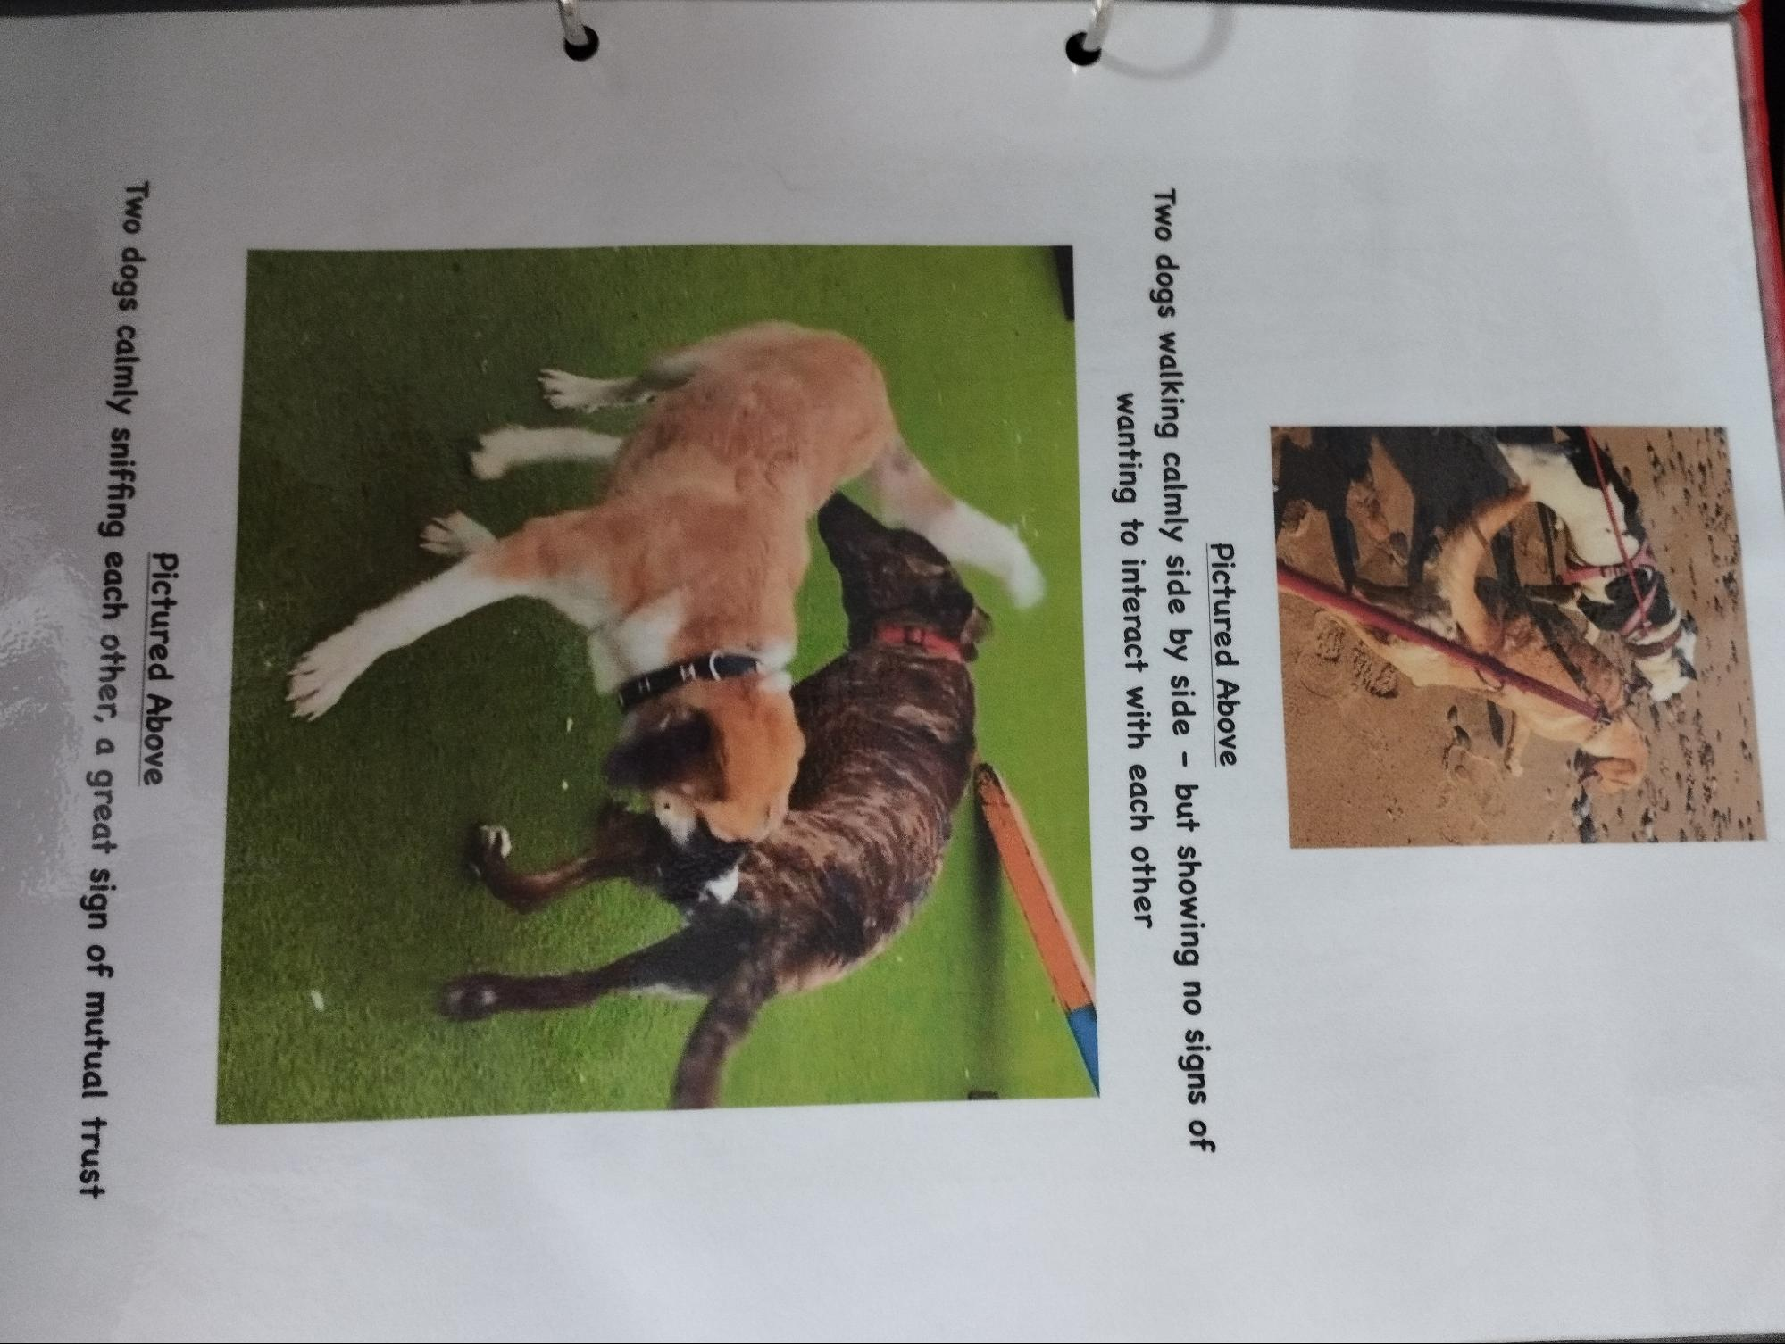
Pictured Above
Two dogs walking calmly side by side - but showing no signs of wanting to interact with each other

Two dogs calmly sniffing each other, a great sign of mutual trust
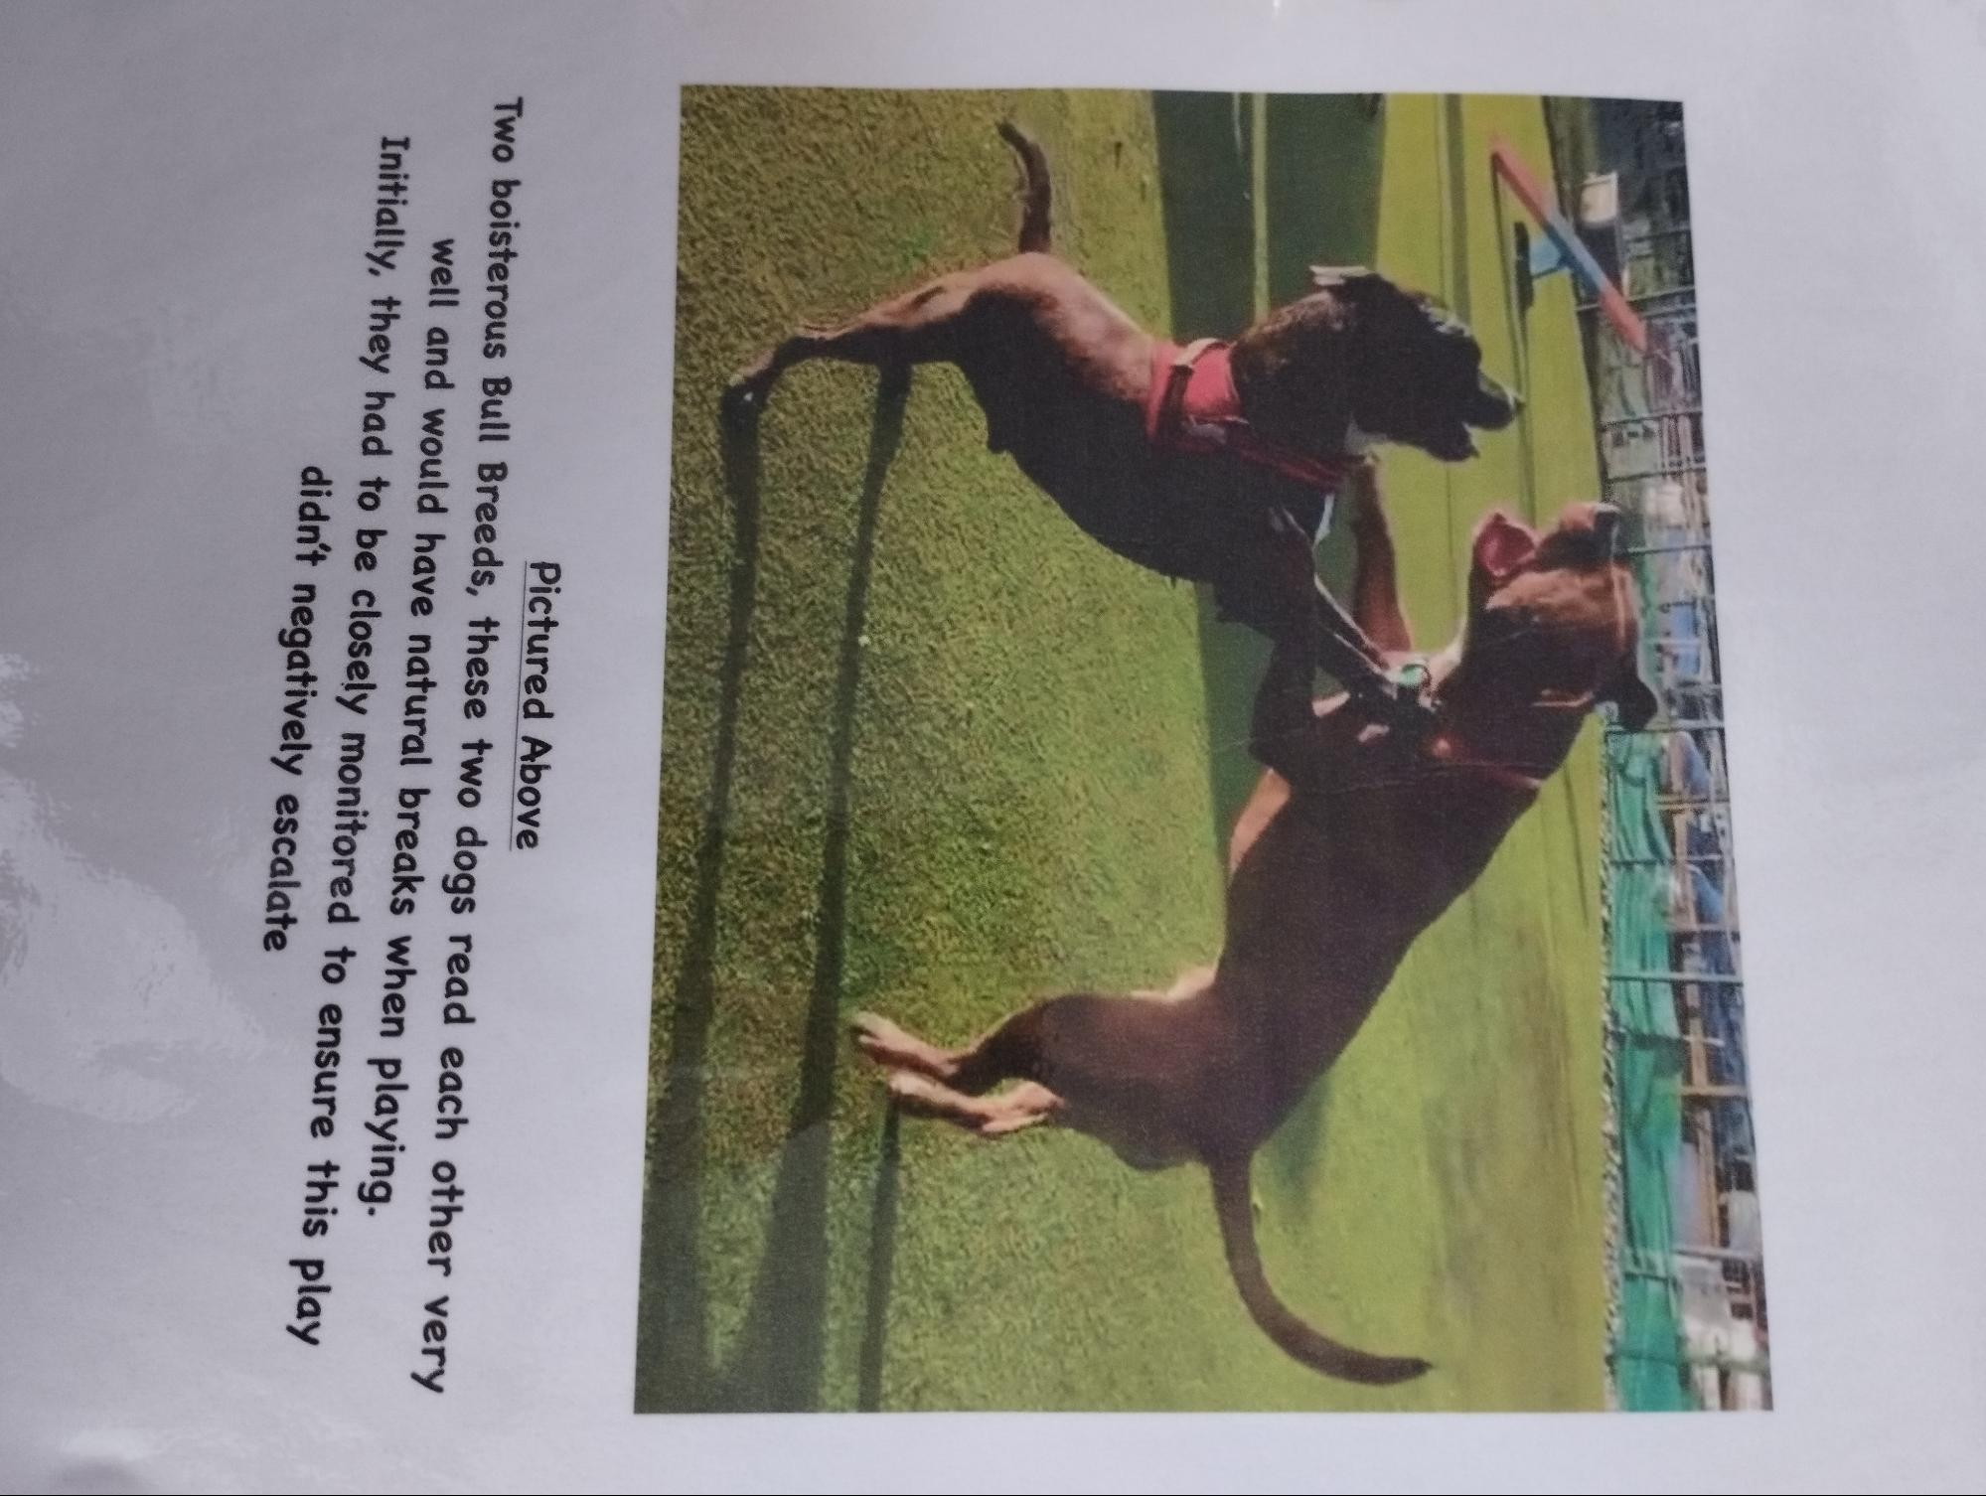
Pictured Above
Two boisterous Bull Breeds, these two dogs read each other very well and would have natural breaks when playing.
Initially, they had to be closely monitored to ensure this play didn't negatively escalate

